**Spatial indicators – data collection survey**

**Project background and aims:**

Urban systems policies in domains such as transport, employment, land use and urban design, housing, public open space, public safety, education and social infrastructure help to shape urban and transport planning and design interventions, which in turn determine transport mode choices and lifestyles, and ultimately exposure to health risks (Giles-Corti et al 2016). A recent *Lancet* paper (Giles-Corti et al 2016) proposed a set of indicators which could be used to measure progress towards creating healthy cities. This research project attempts to measure both common policy indicators and spatial built environment indicators set out in that paper. The objective is to publish this work in the *Lancet*, which has expressed interest in reviewing a paper, or another high-impact journal.

This initial stage of the project engages the IPEN investigator team and associated researchers to assist with data collection and analysis in IPEN cities worldwide. For the spatial indicators Dr Jonathan Arundel will work with colleagues in each participating IPEN city to find and collect spatial data. Results from this demonstration project will be used to guide development of refined measures and processes for collecting similar data much more broadly across the world.

**Spatial indicators:**

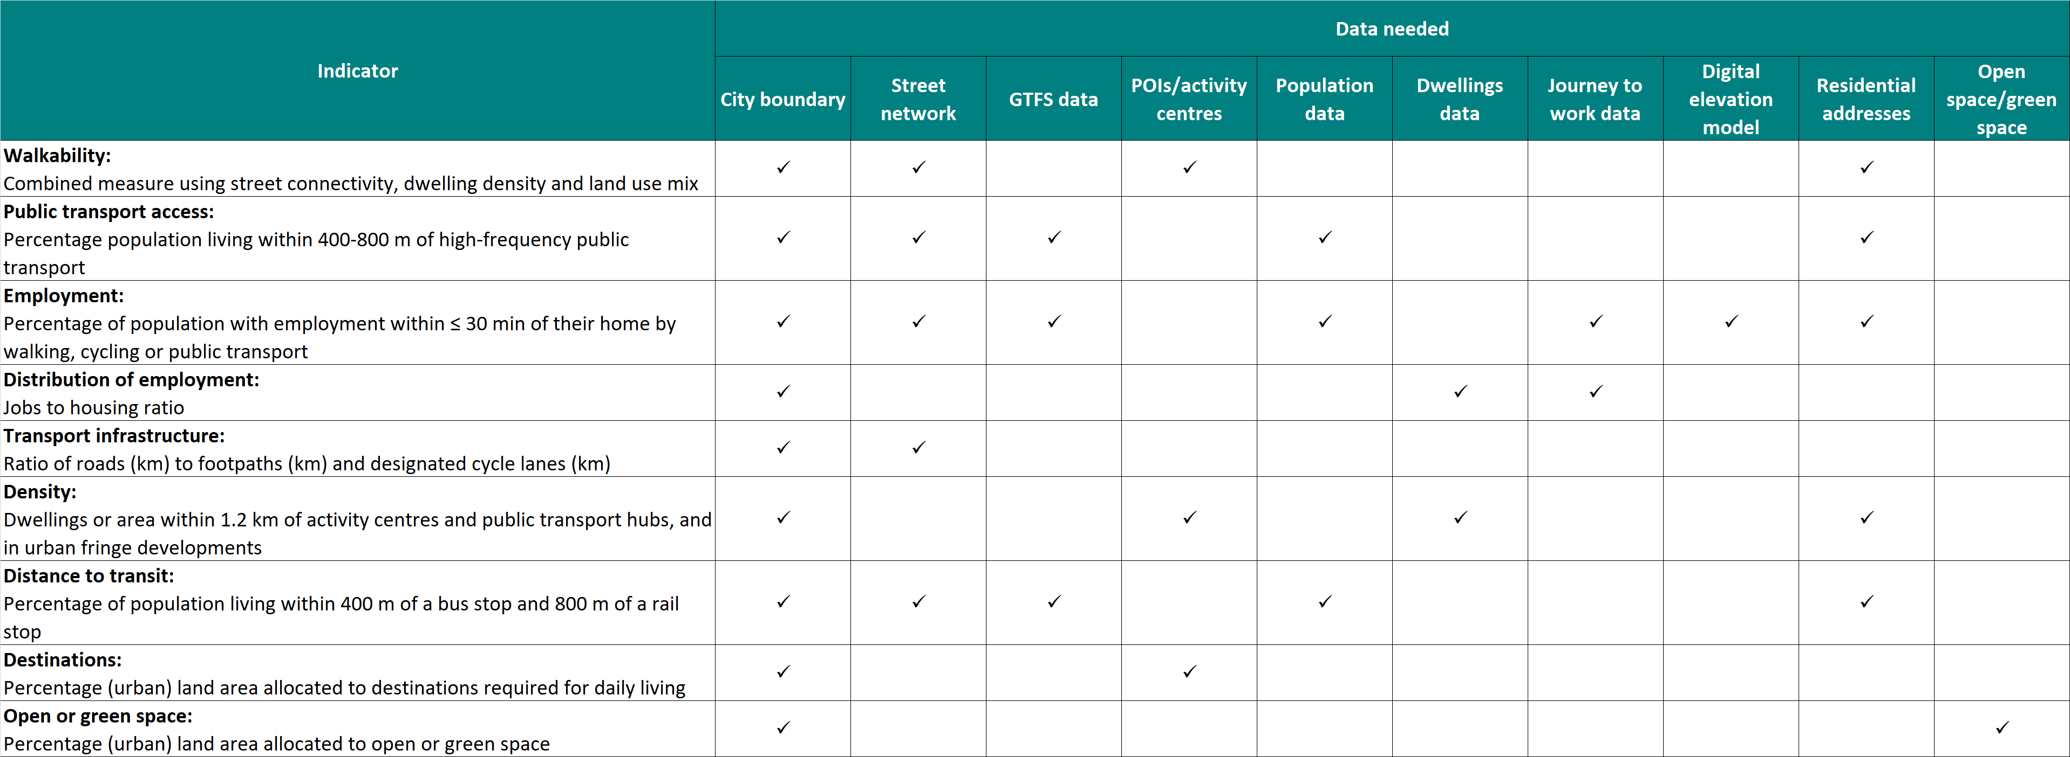

**Instructions:**

Please answer each question below to the best of your knowledge. There is a section at the end of the questionnaire for you to provide additional information. Please also note that we do not require any actual spatial data at this stage of the project; the purpose of this questionnaire is to assess what data are (or are likely to be) available.

Training and support for the actual spatial data collection to commence in the next stage of the project will be offered by Dr Jonathan Arundel. Jonathan is based in Melbourne, Australia and can be contacted via email at jonathan.arundel@rmit.edu.au.

**Were any current team members directly involved in the earlier IPEN spatial indicators project (Adams et al. 2014)?**

Yes

No

**For which of the following technologies and applications do you have experience within the team?**

ArcGIS

QGIS

PostGIS

GDAL/OGR

Python

Other: __________________________________________________

**Our plan is to use a range of open source tools and technologies to calculate as many of the indicators centrally as possible, and make these tools available to collaborators. Please indicate which of the following candidate technologies would be of most interest for your team.**

QGIS

PostGIS

GDAL/OGR

Navitia

OSMnx

OpenTripPlanner

Leaflet

GeoNode

KNIME

Other: __________________________________________________

**Including indicators developed in the previous project (Adams et al. 2014), please upload a file summarising any spatial indicators you have previously calculated for your city and would be willing to share within this project. Please include domain (e.g. walkability), brief description, scales available, and year (e.g. 2014). Data sharing agreements will be put in place as needed.**

**Census data:**

Census data will be important in calculating some of the Lancet indicators. The following section aims to identify available census data and spatial scales.

**Is a census conducted that provides data for your city?**

Yes

No

**How frequently are censuses conducted?**

**What is the year of the last available Census data?**

**For each of the following, what are the spatial scales at which data are available? For example, if dwellings data are available only at suburb or regional level, then the last two columns only should be ticked. As a guide, a neighbourhood can be considered to have between 200 - 800 people, a suburb between 3,000 - 25,000 people and a region 30,000 or more people.**

Population

Dwellings

Employment

Journey to work

**Are spatial boundaries that match to the above census data available openly?**

Yes

No

Maybe/not sure

**Is there a defined spatial boundary for your city as a whole?**

Yes

No

Maybe/not sure

**Are there any restrictions or barriers to the use of the above data by researchers outside of your country?**

Data sovereignty

Data licensing

Language

Other: __________________________________________________

**Open data:**

This section aims to capture information on the extent to which open data (both spatial and non-spatial) are available.

**At which of the following levels are there Government policies promoting open data?**

National (e.g. Australia)

State/Regional (e.g. Victoria)

Metropolitan (e.g. Melbourne)

Local Government

Other: __________________________________________________

**At which of the following levels are data (including spatial data) currently available openly?**

National (e.g. Australia)

State/Regional (e.g. Victoria)

Metropolitan (e.g. Melbourne)

Local Government

Other: __________________________________________________

**Does your team have experience using Open Street Map data for your city? If so, what insights do you have about its accuracy and coverage?**

**Does your team have experience using the GTFS public transport data for your city? If so, what insights do you have about its accuracy and coverage?**

**Other spatial data sets:**

While Open Street Map contains data on roads, cycle and walking paths, and points of interest (such as supermarkets or convenience stores), there may be other sources (including official sources) for this data. Please indicate any knowledge of or experience using these alternative data sets, including how they compare with data available from Open Street Map.

**Is there an official or other source of data for road networks in your city? How does this compare to Open Street Map, and are there costs involved in using these data city wide?**

**Is there an official or other source of data for cycle lanes and pathways in your city? How does this compare to Open Street Map, and are there costs involved in using these data city wide?**

**Is there an official or other source of data for pedestrian networks including footpaths, overpasses and underpasses in your city? How does this compare to Open Street Map, and are there costs involved in using these data city wide?**

**Is there an official or other source of data for public open space in your city? How does this compare to the parks data available in Open Street Map, and are there costs involved in using these data city wide?**

**Is there an official or other source of data for points of interest (e.g. supermarkets) in your city? How does this compare to the data available in Open Street Map, and are there costs involved in using these data city wide?**

**Is there an official or other source of data for geocoded address points in your city (for example, a latitude/longitude for each and every residential address)? If so, are there costs involved in using this data city wide?**

**Is there an official or other source of Digital Elevation Model data for your city? If so, are there costs involved in using this data city wide?**

**Data dissemination**

The aim of this section is to understand channels for disseminating research findings.

For your location, at which levels do portals currently exist for viewing spatial data and indicators?

National (e.g. Australia)

State/Regional (e.g. Victoria)

Metropolitan (e.g. Melbourne)

Local Government

Other: __________________________________________________

For the above portal/s, who is able to publish data to the portals?

Government employees

Researchers

Private organisations

Members of the general community

Other: __________________________________________________